**Pattern Problems**

***1.Write a program to draw the following pattern.***

**\***

**\* \***

**\* * \***

**\* * * \***

**\* * * * \***

#include<stdio.h>

int main ()

{

int i,j;

for(i=1; i<=5; i++)

{

for(j=1; j<=i; j++)

printf("* ");

printf("\n");

}

return 0;

}

***2***. ***Write a program to draw the following pattern.***

***\****

* *

* * *

* * * *

* * * * *

#include<stdio.h>

int main ()

{

int i,j;

for(i=1; i<=5; i++)

{

for(j=5; j>=1; j--)

{

if(j<=i)

printf("*");

else

printf(" ");

}

printf("\n");

}

return 0;

}

***3. Write a program to draw the following pattern.***

* * * * *

* * * *

* * *

* *

*

#include<stdio.h>

int main ()

{

int i,j;

for(i=1; i<=5; i++)

{

for(j=5; j>=1; j--)

{

if(j>=i)

printf("*");

else

printf(" ");

}

printf("\n");

}

return 0;

}

***4. Write a program to draw the following pattern.***

* * * * *

* * * *

* * *

* *

*

#include<stdio.h>

int main ()

{

int i,j;

for(i=1; i<=5; i++)

{

for(j=1; j<=5; j++)

{

if(j>=i)

printf("*");

else

printf(" ");

}

printf("\n");

}

return 0;

}

***5. Write a program to draw the following pattern.***

*

* * *

* * * * *

* * * * * * *

* * * * * * * * *

#include<stdio.h>

int main ()

{

int i,j;

for(i=0; i<5; i++)

{

for(j=0; j<9; j++)

{

if(j>=4-i && j<=4+i)

printf("*");

else

printf(" ");

}

printf("\n");

}

return 0;

}

***6. Write a program to draw the following pattern.***

* * * * * * * * *

* * * * * * *

* * * * *

* * *

*

#include<stdio.h>

int main ()

{

int i,j;

for(i=0; i<5; i++)

{

for(j=0; j<9; j++)

{

if(j>=i && j<=8-i)

printf("*");

else

printf(" ");

}

printf("\n");

}

return 0;

}

***7. Write a program to draw the following pattern.***

* * * * * * * * * *

* * * * * * * *

* * * * * *

* * * *

* *

#include<stdio.h>

int main ()

{

int i,j;

for(i=0; i<5; i++)

{

for(j=0; j<10; j++)

{

if((i==0) || (j>=0 && j<=4-i) || (j>=5+i && j<=9))

printf("*");

else

printf(" ");

}

printf("\n");

}

return 0;

}

***8. Write a program to draw the following number pattern.***

1

1 2 1

1 2 3 2 1

1 2 3 4 3 2 1

#include<stdio.h>

int main ()

{

int i,j,count;

for(i=0; i<4; i++)

{

count=1;

for(j=0; j<(3-i); j++)

printf(" ");

for(j=1; j<=i; j++)

printf("%d",count++);

while(count)

printf("%d",count--);

printf("\n");

}

return 0;

}

***9. Write a program to draw the following number pattern.***

1 2 3 4 3 2 1

1 2 3 2 1

1 2 1

1

#include<stdio.h>

int main ()

{

int i,j,count;

for(i=0; i<4; i++)

{

count=1;

for(j=0; j<=6; j++)

{

if((j>=i && j<=i-1) || (j>=7-i && j<=6))

printf(" ");

}

for(j=i; j<3; j++)

printf("%d",count++);

while(count)

printf("%d",count--);

printf("\n");

}

return 0;

}

***10. Write a program to draw the following Alphabet pattern.***

1234321

123 321

12 21

1 1

#include<stdio.h>

int main ()

{

int i,j,count;

for(i=0; i<=3; i++)

{

count=1;

for(j=0; j<=(3-i); j++)

printf("%d",count++);

for(j=0; j<=6; j++)

{

if(i!=0 && (j>=4-i && j<=2+i))

printf(" ");

}

for(j=0; j<4-i; j++)

{

if(count==5)

{

count=count-2;

printf("%d",count);

}

else if(i==0 && j==3)

break;

else

printf("%d",--count);

}

printf("\n");

}

return 0;

}

***11. Write a program to draw the following Alphabet pattern.***

A

A B A

A B C B A

A B C D C B A

A B C D E D C B A

#include<stdio.h>

int main ()

{

int i,j;

char ch;

for(i=0; i<=4; i++)

{

ch='A';

for(j=0; j<=4; j++)

if(i!=4 && (j>=0 && j<=3-i))

printf(" ");

for(j=1; j<=i; j++)

printf("%c",ch++);

for(j=0; j<=i; j++)

printf("%c",ch--);

printf("\n");

}

return 0;

}

***12. Write a program to draw the following Alphabet pattern.***

A B C D C B A

A B C B A

A B A

A

#include<stdio.h>

int main ()

{

int i,j;

char ch;

for(i=0; i<=3; i++)

{

ch='A';

for(j=0; j<=3; j++)

if(i!=0 && (j>=0 && j<=i-1))

printf(" ");

for(j=1; j<=(3-i); j++)

printf("%c",ch++);

for(j=0; j<=(3-i); j++)

printf("%c",ch--);

printf("\n");

}

return 0;

}

***13. Write a program to draw the following Alphabet pattern.***

ABCDEFGFEDCBA

ABCDEF FEDCBA

ABCDE EDCBA

ABCD DCBA

ABC CBA

AB BA

A A

#include<stdio.h>

int main ()

{

int i,j;

char ch;

for(i=0; i<=6; i++)

{

ch='A';

for(j=0; j<=(6-i); j++)

printf("%c",ch++);

for(j=0; j<=12; j++)

if(i!=0 && (j>=7-i && j<=5+i))

printf(" ");

for(j=0; j<=(6-i); j++)

{

if(ch=='H')

{

ch=ch-2;

printf("%c",ch);

}

else if(i==0 && j==6)

break;

else

printf("%c",--ch);

}

printf("\n");

}

return 0;

}

***14. Write a program to draw the following Alphabet pattern.***

*

* *

* *

* *

* * * * *

#include<stdio.h>

int main ()

{

int i,j;

for(i=0; i<=4; i++)

{

for(j=0; j<=i; j++)

if((i>=2 && i<=3) && (j>=1 && j<=i-1))

printf(" ");

else

printf("*");

printf("\n");

}

return 0;

}

***15. Write a program to draw the following Star pattern.***

***\****

* *

* *

* *

* * * * *

#include<stdio.h>

int main ()

{

int i,j;

for(i=0; i<=4; i++)

{

for(j=0; j<=4; j++)

if((j>=0 && j<=3-i) || ((i>=2 && i<=3) && (j>=5-i && j<=3)))

printf(" ");

else

printf("*");

printf("\n");

}

return 0;

}

***16. Write a program to draw the following star pattern.***

*

* *

* *

* *

* * * * * * * * *

#include<stdio.h>

int main ()

{

int i,j;

for(i=0; i<=4; i++)

{

for(j=0; j<=(4+i); j++)

if(i!=4 && (j>=0 && j<=3-i))

printf(" ");

else if((i>=1 && i<=3) && (j>=5-i && j<=3+i))

printf(" ");

else

printf("*");

printf("\n");

}

return 0;

}

***17. Write a program to draw the following star pattern.***

* * * * * * * * *

* *

* *

* *

*

#include<stdio.h>

int main ()

{

int i,j;

for(i=0; i<=4; i++)

{

for(j=0; j<=(8-i); j++)

if(i!=0 && (j>=0 && j<=i-1))

printf(" ");

else if((i>=1 && i<=3) && (j>=i+1 && j<=7-i))

printf(" ");

else

printf("*");

printf("\n");

}

return 0;

}

***18. Write a program to draw the following star pattern.***

*

* * *

* * * * *

* * * * * * *

* * * * * * * * *

* * * * * * *

* * * * *

* * *

*

#include<stdio.h>

int main ()

{

int i,j;

for(i=0; i<=4; i++)

{

for(j=0; j<=(4+i); j++)

if(i!=4 && (j>=0 && j<=3-i))

printf(" ");

else

printf("*");

printf("\n");

}

for(i=0; i<=3; i++)

{

for(j=0; j<=(7-i); j++)

if(j>=0 && j<=i)

printf(" ");

else

printf("*");

printf("\n");

}

return 0;

}

***19. Write a program to draw the following heard pattern.***

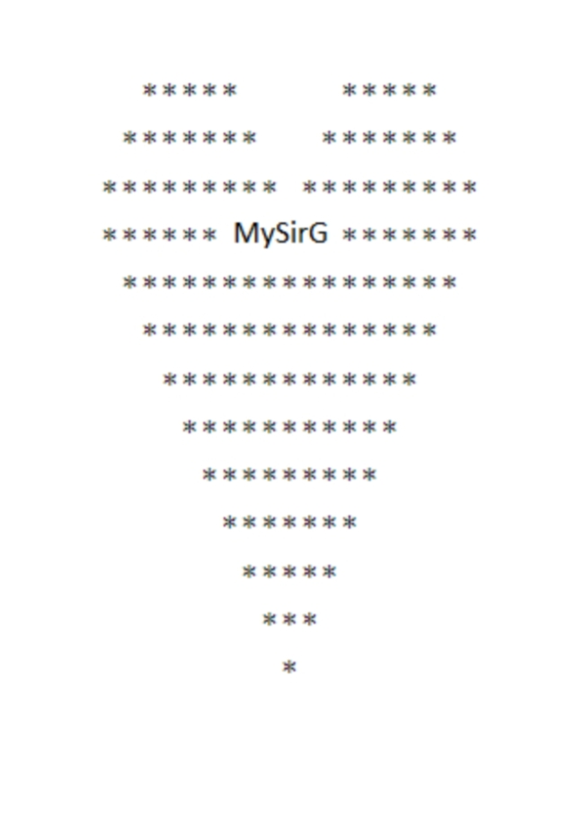

#include<stdio.h>

int main ()

{

int i,j;

for(i=0; i<=2; i++)

{

for(j=0; j<=(16+i); j++)

if((i>=0 && i<=1) && (j>=0 && j<=1-i) || (j>=7+i && j<=11-i))

printf(" ");

else

printf("*");

printf("\n");

}

for(i=0; i<=9; i++)

{

for(j=0; j<=(18-i); j++)

if(i==0 && (j>=6 && j<=11))

{

printf("MySirG");

for(j=0; j<=6; j++)

printf("*");

break;

}

else if(i!=0 && (j>=0 && j<=i-1))

printf(" ");

else

printf("*");

printf("\n");

}

return 0;

}